# Exercises: Filters

Problems for exercises and homework for the [“C# MVC Frameworks - ASP.NET” course @ SoftUni](https://softuni.bg/trainings/1537/csharp-mvc-frameworks-asp-net-march-2017).

## Custom Errors

Change the **default view** that is displayed when exception is thrown in any of the action methods. Make the view look more friendly to the user and show only the exception message without the stack trace.

### Example

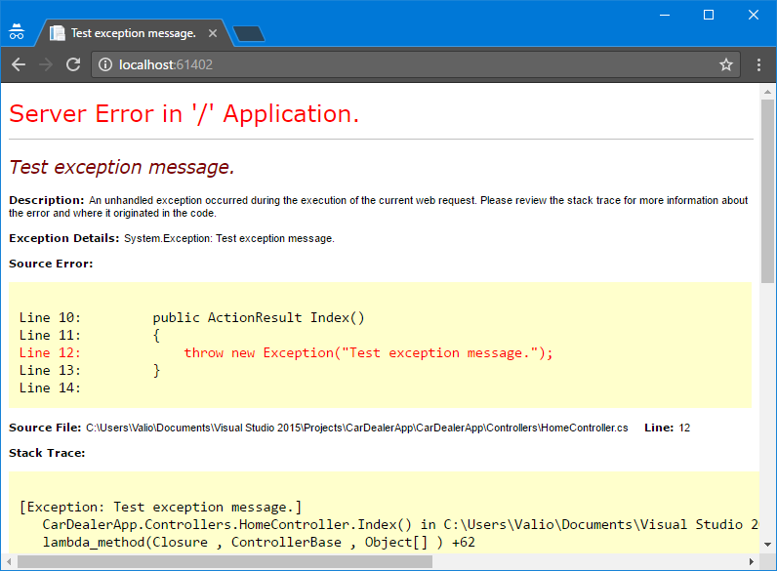

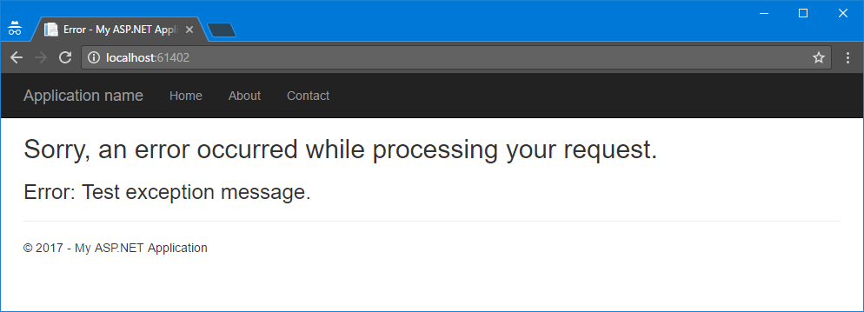

### Hints

* Create new **View** that should display **only the exception message**
* Use the **default filter** that handles exceptions but **change its default view** with the one you created

## Range Exception Filter

Setup the HandleError attribute on an action method to handle only ArgumentOutOfRangeException. When such exception occurs show to the user customized view. If any other exception occurs the default error view should be shown.

### Examples

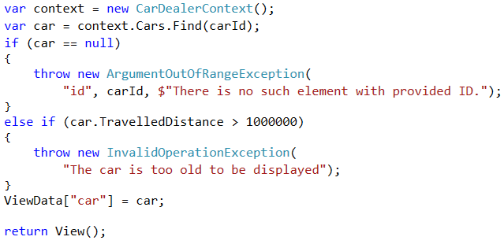

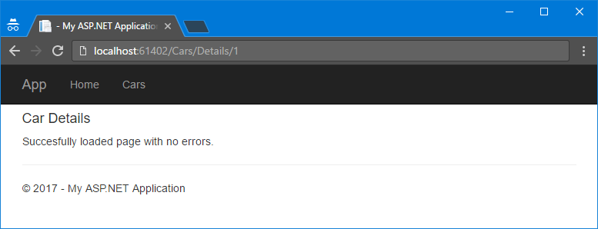

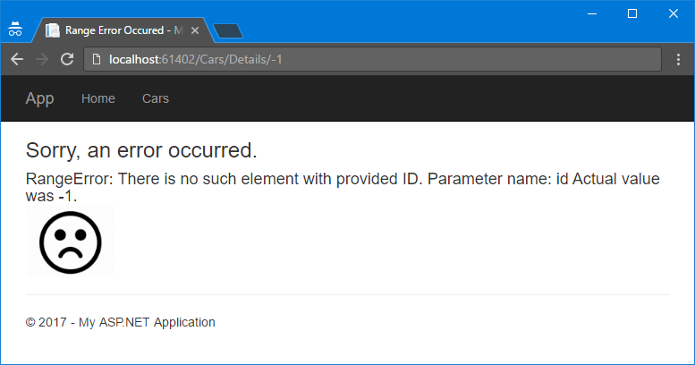

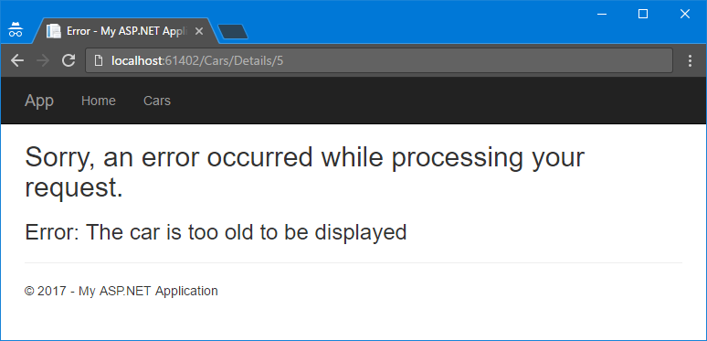

## Log Filter

Create custom action **filter** that **logs action when it is performed**. For each log, you should keep information about:

* **Date and time** when the action method was executed
* **IP address** of the user who sends the request
* **User** – name of the user who executed that action or if the user is not logged in print “anonymous”
* **Controller** and **action**
* **Exception** **type** and **message** if there is any

Use the following format for each log.

* Log after **successful execution** of an action:

{date and time} – {IP Address} – {User/Anonymous} – {Controller}.{action}

* Log format when **exception** is thrown:

[!] {date and time} – {IP Address} – {User/Anonymous} – {Controller}.{action} - {Exception type} – {Exception Message}

Logs should be saved in a file **logs.txt.**

Try logging only execution of **some actions**. Then try to log execution of **all actions** in given controller. Finally set the logging **globally** to the whole application.

### Example

|  |
| --- |
| **logs.txt** |
| 2017-03-02 10:00:00 – 192.168.0.1 – Anonymous – HomeController.Index  2017-03-02 10:13:12 – ::1 – Anonymous – HomeController.Contacts  2017-03-02 12:10:00 – 128.128.128.14 – Anonymous – AccountsController.Login  2017-03-02 12:10:20 – 128.128.128.14 – Dragon123 – AccountsController.Edit  2017-03-02 12:11:20 – 128.128.128.14 – Dragon123 – AccountsController.ChangePassword  2017-03-02 12:12:20 – 128.123.192.16 – Pesho – HomeController.Index  [!] 2017-03-02 13:10:20 – 128.128.128.14 – Dragon123 – CarsController.Details – ArgumentOutOfRangeException – Could not find a car with ID -1  [!] 2017-03-02 14:00:00 – ::1 – Anonymous – AccountsController.Edit – UnauthenticatedException – You must be logged in to access the page |

## Timer Filter

Create custom **filter Timer** that **measures** the time that the **action method takes to execute**. Saves the results in a file called **action-times.txt**.

Each **record** should be in format:

{date and time} – {Controller}.{Action} – {elapsed time}

### Example

|  |
| --- |
| **action-times.txt** |
| 2017-03-02 10:00:00 – GamesController.All – 00:00:00.5016221  2017-03-02 10:01:00 – HomeController.Index – 00:00:00.0038162  2017-03-02 10:00:00 – GamesController.All – 00:00:00.5213425  2017-03-02 10:00:00 – GamesController.All – 00:00:00.4916991 |